PROJECT PLAN: GROUP 12

Authors: bea16, dpb1, alh32, fik, anp28, srp11, lps1, lot15, thw10
Config Ref: SE_12_PP_01
Date: 27/01/2014
Version: 1.1
Status: Final

Table of Contents
1. INTRODUCTION 3
1.1 Purpose of this Document 3
1.2 Scope 3
1.3 Objectives 3
2. OVERVIEW OF THE PROPOSED SYSTEM 4
2.1 Overview of the web system 4
2.2 Overview of the Android system 6
3. USE CASE DIAGRAMS 7
3.1 Android use case 7
3.2 Web use case 9
4. User Interface Design 11
4.1 Web user interface 11
4.2 Android User Interface 16
5. GANNT CHART 18
6. Risk Analysis 19
6.1 Preliminary risk analysis 19
6.2 Life-cycle risk analysis 19
6.3 Operational risk analysis 20
7 REFERENCES 20
APPENDICES 20
Document history 20

1. INTRODUCTION

1.1 Purpose of this Document
This document is here to ensure that the application we intend to build, a walking tour creator application for android, fully meets the requirement specification, as given by the client. It will help make sure that we cover all necessary features and that a quality product in produced.
This document will also outline how parts of the application will interact, along with how the user interface will actually look. As well as this, the document will highlight the project schedule, showing the major tasks to be completed, along with when each task needs to be achieved by. This will be displayed in the form of a Gantt chart.

1.2 Scope
This document should be read by the client, with reference to the requirement specification to ensure that what we intend to build meets what they expect us to build.
This document contains the following sections:

Overview of the proposed system: This section will show how both the web and phone applications will run and what will include descriptions on the functionalities of the system.

Use Case diagrams: This will show how every part of the program will interact and the links that must be in place for successful operation.

User interface design: This section will show how the finished application will look, as well as giving an idea of how it will feel to use. It will help ensure that the navigation and use of the app is simple, but suitable.

Gantt chart: In this section the major tasks will be made clear, along with when each task needs to be started and completed.

Risk analysis: This section stands to outline the possible problems we may encounter throughout this project, and how these problems can be avoided or solved.

1.3 Objectives
This document is here to show our preliminary plan for the proposed system and show that we have interpreted and understood the clients requirement specification.
The objectives this document has are:

- To give an summary of the project and the procedures, technologies and languages we will be using.
- To show the how each main part of the project with join together and interact.
- To display what we aim for the user interface to include, as well as how it will look when finished.
- To give a plan, with a schedule, of the tasks and milestones that need to be accomplished throughout the project.
- To highlight and understand possible issues with the project, and avoid them where feasible.

2. OVERVIEW OF THE PROPOSED SYSTEM

2.1 Overview of the web system
PHP - Phone will upload all data to a HTML file for a PHP file to parse from. PHP files will be able to create a connection to our database at db.dcs.aber.ac.uk and pass all relevant items of information into the tables according to the needs of the data. The phone can upload through a login system using a combination of POST data retrieved from a HTML file and used through a PHP page. PHP front end will include pages for registration of users to our user field and fill out the necessary details, this will go straight to the table associated with users and be stored for later use alongside a unique field ID to remember individual users. This will be a one time requirement for future use of the system. The login page will then be used in later access to the service. Login will instead use SELECT functions and retrieve data from the table, should it match the expectations then the user will be allowed to access their account. Other pages will use other tables such as those containing the paths of the user, and the points associated with those. During use of the system the information posted to the HTML page from the phone will be used to INSERT INTO the tables for paths and points.
MySQL – Connect to dcs.db.aber.ac.uk, allows information to be stored and retrieved for later use. We have a database and a login for it now, there is also a portable test database on the backend web developer's USB drive. The dummy can be used to store false data for retrieval and allow us to commit tests to strain our real database before use. Series of queries will be required to make use of the database. Must include fields for point descriptions, names, latitude, longitude, images associated with the point of interest, and path associated with the point, and in what order the point occurs.
Connectivity – Phone must automatically acknowledge a loss in connection to either Mobile or WiFi services. If lost during an attempted retrieval or transmission of information. If unsuccessful then prompt the user a failed attempt at transfer, or return confirmation upon success. Must also store transmission information for return of connectivity, so a post can be made on the user's request.
Menu – Must provide paths to all tools that the user will need, links to registration page, login, path editing and new paths, deleting paths, viewing paths. Menu should be visibly pleasing to the user and simple to use. Icons should make sense and be straightforward.
Login – Must consist of a unique ID and hash code obtained via a relevant social media interface. We plan to use a social media website's authentications to allow the user to log in. A unique hash will be passed forward from the social media services to authenticate the user for access to the system. This hash can be stored in our SQL database and will be returned each time a user wishes to access the system.

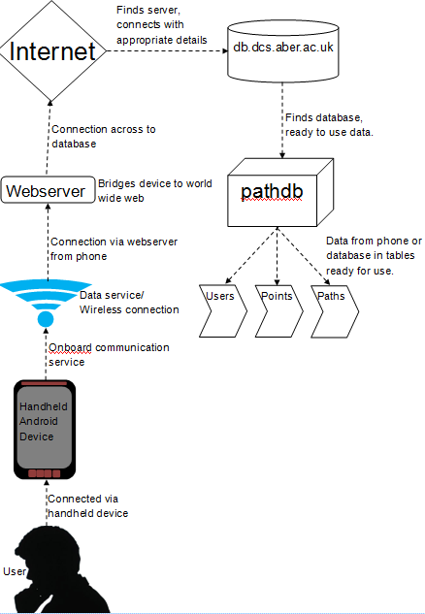Figure 1: Deployment Diagram showing the system.

2.2 Overview of the Android system
The android application is expected to have the following:

Log In/Register

This is where users can create an account or use their existing account to access the program. The information the user passes to us here needs to get sent to the database to check to see if it is all correct information.

GPS Map View

This will allow the user to see where they are currently positioned on Google Maps. This is likely to
be automatically on screen as the user records a walk. When the walk is finished, they will be able to look at the map to see where they started and ended walking. An arrow or marker will point to any significant locations that the User has chosen to landmark on the way.

Local Walk Data

This is where walk information will be stored before the walk information such as Walk name, Journey time and the Descriptions of the walk has been sent to the database. This is important in case of a connectivity failure to prevent.

Uploading Walks

Users may select a walk to upload to the server. The entire data contained within the walk is synchronised with the database on the server.

Recording Walks

Users, while recording their walks will store information as local data on the hand-held device. This prevents any information from being lost due to a connectivity error. Users will also be able to record walks offline due to this feature. Users will be able to take photos, choose significant landmarks and write descriptions about each walk here.

Editing Walks

User may change details about their walks before finally sending the information to the server. Here they can add a large description to their walk and can delete any walks they are unhappy with.

These will be explained further in the user interface design section.

3. USE CASE DIAGRAMS

3.1 Android use case
Figure below shows the use case diagram for the android client. It describes the functions that the user will be allowed to use on the android app and a description of what each function does.

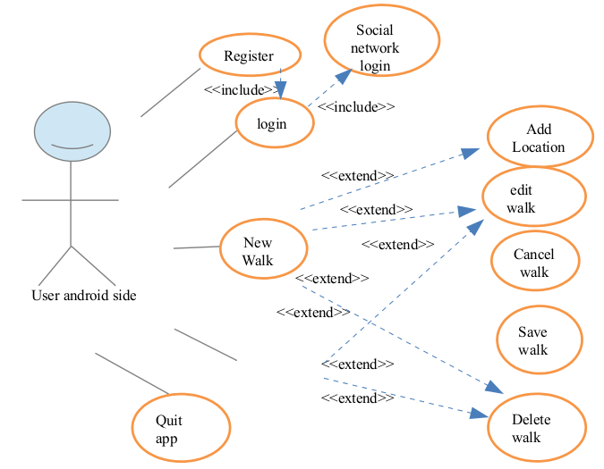Figure 2: Use Case diagram for the android side.
Log in

If the app is running for the first time on the device, a choice will be given to the user to register or sign in. Upon signing in a login request is sent to the server and a value of 0 or 1 returned. If authenticated, the user can then access the full application. If the authentication has failed a fail message will appear and prompt the user retry or to register. If re-try is selected they will be returned to the log-in screen, if register is selected then they will be referred to the Register User page.
Register User

The user will be shown a screen asking for details such as a user name, password and email address. Both the email address and password will then be encrypted when the submit button if pressed and a request will be sent to the server to check that the details don't conflict with existing data in any of the tables. The server will then return a token. Depending on the token a message box will warn the user that the information already exists and asked to change that field or that the information was correct and a new account has been created for them.

Record new walk

When a new walk is selected the user will be asked to enter information about the walk such as the walk name and a short description. When the user confirms the information inputted a snapshot of the time and GPS location will be taken and a request will be stored locally on the device.

Add point of interest

When the user adds a point of interest a location description, name will be asked for. An integer will be stored for the order of locations, the Lat and long co-ordinates and the date and time. The user will then be given a choice to take a photo or enter Audio, both of which will also be stored locally.

Cancel recording

If the recording is cancelled the data stored locally on the device will be removed, a message will notify the user that the walk has been cancelled.

Save recording

When the walk is complete and the user saves the walk then they will be asked for a long description of the walk and the user has checked and confirmed the information all the data will be sent to the data base. If no connection can be made then a message will appear warning the user that it could not connect to the server. If a successful connection is made, a request will be sent to the server to add the local information to the database.
The server will then return a token of 1 or 0. If Successful the local data will be removed otherwise a warning will tell the user that there was an error with the server and to try later and keep the local data stored to the device.

Review walk

The user will be given the option to review a walk. A request will be sent to server and a list box will be populated with the names of walks. When a walk is selected a map will be loaded with simple walk details, such as name, description, stat location etc. The user will be able to zoom in and out and look at the locations of the walk and be able to select that as a walk. If a walk is selected the full walk details will be requested from the server.

Delete walk

If a user is not happy with walks that they have recorded they will be given the choice to delete the walk from a drop box. A request will be sent to server to remove the walk from the database. The server will return a value and a message will appear telling the user if it was successful or not.

3.2 Web use case
Below describes the interactions the client program has with the server. It does not describe the
administrative functions, since these will probably be performed by a special, direct client. Note: Although there is a little figure of a person on the diagram, this is actually two programs talking to each other.

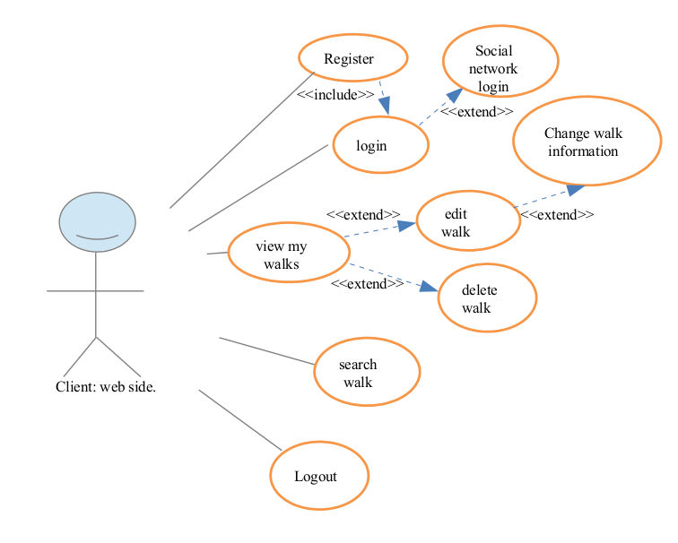Figure 3: Use Case diagram for the web side of the system
Register

A button will be on website will a user to register, a Message box will prompt the user for a username, password and email address. The email and password will then be encrypted and a request will be sent to the server. The information will then be check against other entries in the database. the server will then return a value. If the value is 0 then a message will be displayed and the user can then access other parts of the website. Depending on the token returned the user may get an error message asking to change a field that clashes with data already stored on the database, such as a username or email.

Login

A login button will allow registered users to enter the username and password. These will then be encrypted and a request will be sent to server to check the information. The server will then return a value. If the authentication is successful the user will be able to access information on walks that they have created. If it fails then they will be asked to retry or to register.

Edit

When the page loads a request is sent to the server to retrieve the information from the server. The user will be presented with a list box populated with their walks. When a walk is selected a request is made to the server to retrieve the full information about the walk, and a map should load with the details. The user should then be able to select points along the walk to add new locations etc.

Search

A search box will allow the user to search through the walks that other people have created with advance search options such as location, time etc.

View

An option to view the users walks will send a request to the sever for a list of walks that the user has made. A listbox will then be populated with the results.

Delete

The user will be able to look through of lists of walks that they have created and select one to be deleted. A message will prompt the user asking if they are sure they want to delete it, if the request is true then a request to the server will ask to remove all data stored related to that walk. The server will send a result confirming the deletion or an error why it couldn't.

4. User Interface Design

4.1 Web user interface
Figure 4: Draft UI of the home page.

Most Popular Walk

Pictures of the waypoints of the most popular walk
Description of the most popular walk
Pictures of the waypoints of the most popular walk
Pictures of the waypoints of the most popular walk

Pictures of the waypoints of the most popular walk
Pictures of the waypoints of the most popular walk
Pictures of the waypoints of the most popular walk

Fig
Figure 5: Draft UI of the registration page

Illustration 6: Draft UI of the walk details page.

Google map of the walk

Brief details of the user

Pictures and short descriptions of way points
Pictures and short descriptions of way points
Pictures and short descriptions of way points

Distance of the walk
Time of the walk
Number of views

Walk details page

Illustration 7: Draft UI of the select walk page.

SELECT THE WALK TO EDIT

Brief user info

Select walk page

Illustration 8: Draft UI of the Search walk page.

Search for walk
Type here

Search result

Brief info on the walk
Picture of a way-point within that walk.

Search result

Brief info on the walk
Picture of a way-point within that walk.

Search result

Brief info on the walk
Picture of a way-point within that walk.

Search walk page

4.2 Android User Interface
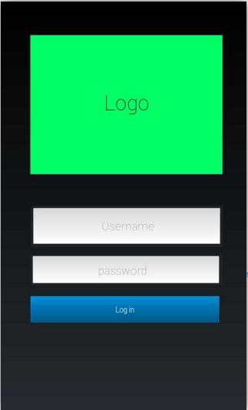Figure 9: Login screen.
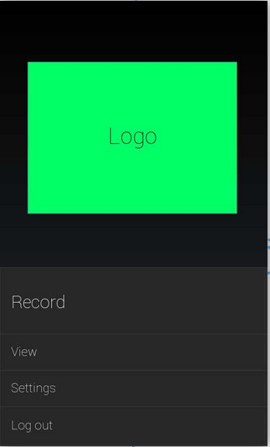Figure 10: Home screen - button for record walk - button for preferences/setting - button to look at the list of recently recorded walks

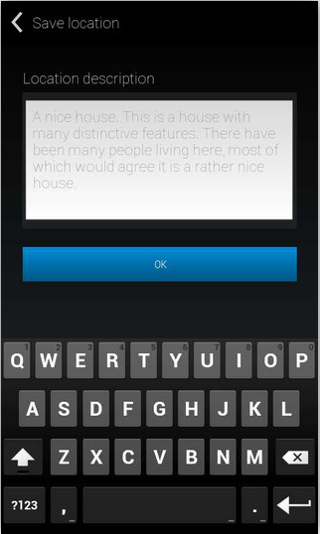Figure 12: Location recording screen - button to take photograph – button to record audio - small wizard prompting for each text entry.
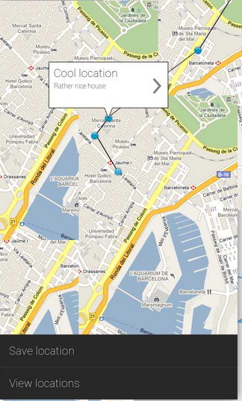Figure 11: Recording screen - map view - button to record location - potentially pause/unpause button

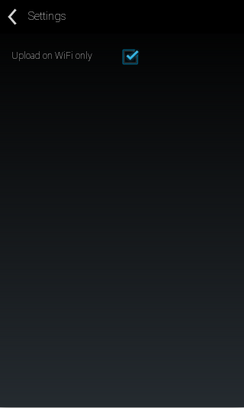Figure 14: Settings screen - some settings buttons - "only upload on wifi".
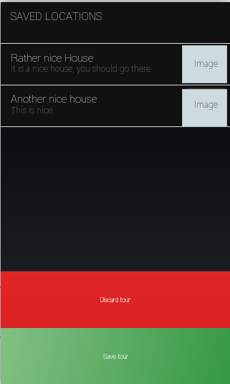Illustration 13: Walk review screen - list of locations recorded - expandable map showing the walking trace - save button.

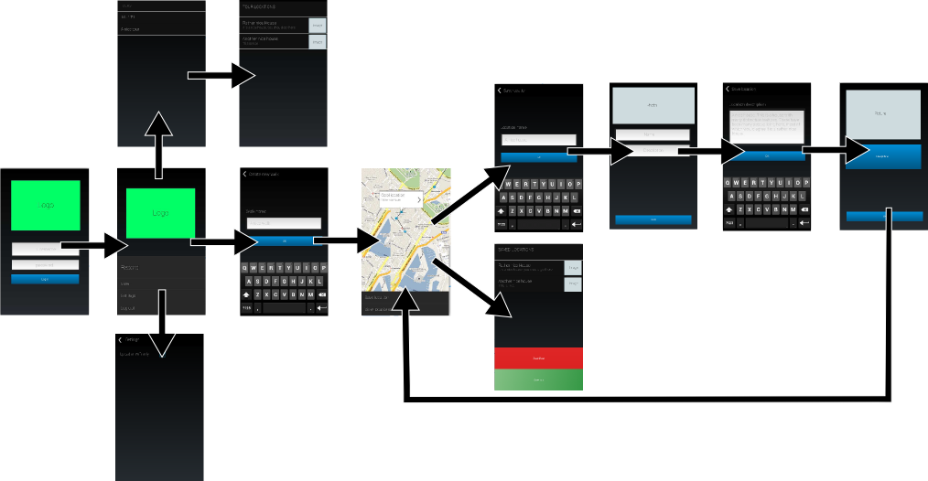Figure 15: Showing how the screens within the Android app will linked together.

5. GANNT CHART
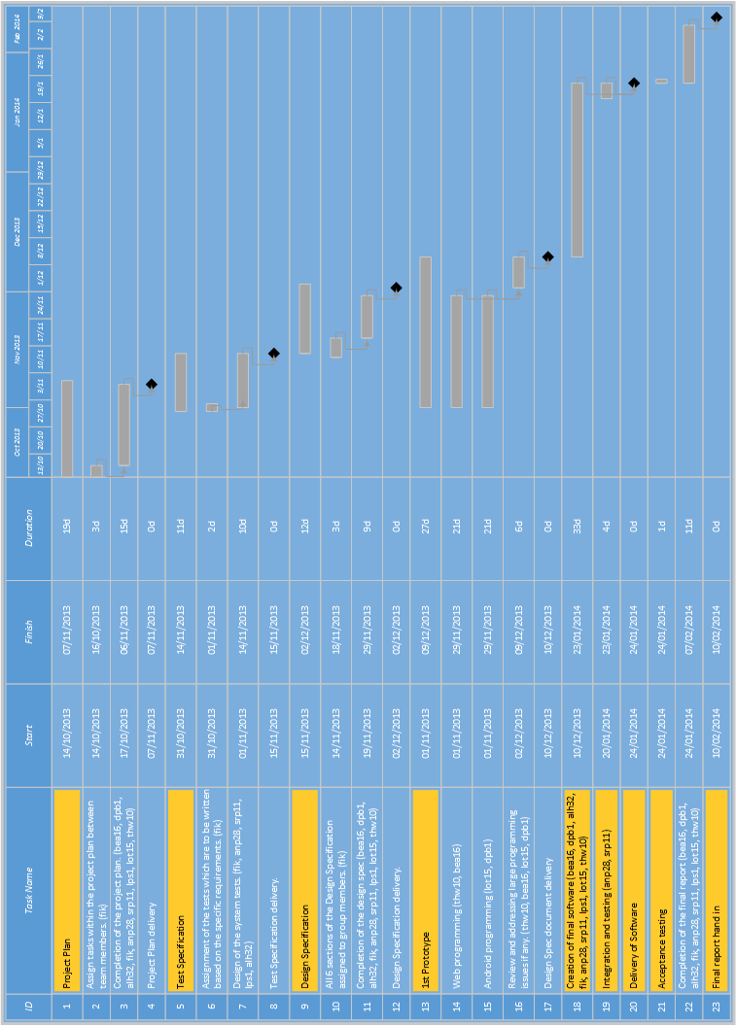

6. Risk Analysis

6.1 Preliminary risk analysis
Risk | Probability | Effects | Strategy
Loss of team member | Low | Serious | Reorganise team with more overlap of duty of each member.
Illness of team member | Moderate | Serious | Reorganise team with more overlap of duty of each member for the period of member illness.
Documentation incomplete/late | Low | Series | Aim to complete parts of documentation well in advance of deadline. If problems occurs contact team members so that they can help to complete / fix errors.
Scale of Project underestimated | Low | Catastrophic | Produce project plan detailing the scale and scope of proposed system.
Requirement change | Low | Tolerable | Communicate with client. Communicate with group / project leader. Re-arrange project to incorporate feature making sure that it does not interfere with project deadline.
Loss of Project Leader | Low | Serious | Restructure team & reorganise duties with more overlap.

6.2 Life-cycle risk analysis
Risk | Probability | Effects | Strategy
Feature Creep | Moderate | Tolerable | Adhere to design documents. If problems occur the development team should communicate with the project leader.
Version control errors due to naivety | High | Tolerable | Make sure that the version control expert fully trains each member of the team & that they understand proper Git use.
Loss of source code | Low | Catastrophic | Use a repository, have multiple backups. Contact project manager if does occurs.
Android Cross Platform Development Issues | Moderate | Tolerable | Agree on specific Android version that the development team will use.
Parts of system late or incomplete | Moderate | Serious | Adhere to Gantt chart and try to complete well in advance of deadline. Communicate with project leader / team.
Parts of system defective | Moderate | Serious | Use proper testing strategies, e.g. Black-box / whitebox. Communicate with team to daft members in to help with fault finding.

6.3 Operational risk analysis

Risk | Probability | Effects | Strategy
Database performance | Low | Serious | Investigate database performance, specifically MySQL vs. PostgreSQL.
Unresponsive UI - outlined in performance requirements (PR1). | Moderate | Serious | Investigate design patterns for responsive Android design.
Unable to send walk via HTTP POST or formatted to MIME specification outlined in functional requirements (FR6). | Low | Serious | Investigate the Multipurpose Internet Mail Extension standard in conjunction with PHP’s $_POST superglobal.
Unable to obtain GPS coordinates. | Low | Serious | Investigate android.location API, specifically the LocationManager class.
GPS consumes too much battery. | Moderate | Tolerable | Investigate Location Strategies especially Network Location Provider.
UI may not be intuitive to regular computer users as outlined in External Interface Requirements (EIR1). | Low | Serious | Test UI, gather & incorporate feedback from test users.

7 REFERENCES
[1] Software Engineering Group Projects. Design Specification Standards. C. J. Price, N.W.Hardy and B.P.Tiddeman. SE.QA.05A. 1.7. Release.

APPENDICES

Document history
Version | CCF No. | Date | Changes made to the document | Changed by
1.0 | N/A | 31/10/13 | N/A Original draft. | fik
1.1 | N/A | 07/11/13 | Changes/updates to each section of the document. | fik
1.2 | SE_12_PP_01 | 27/01/14 | Corrected major formatting issues. | LPS1

